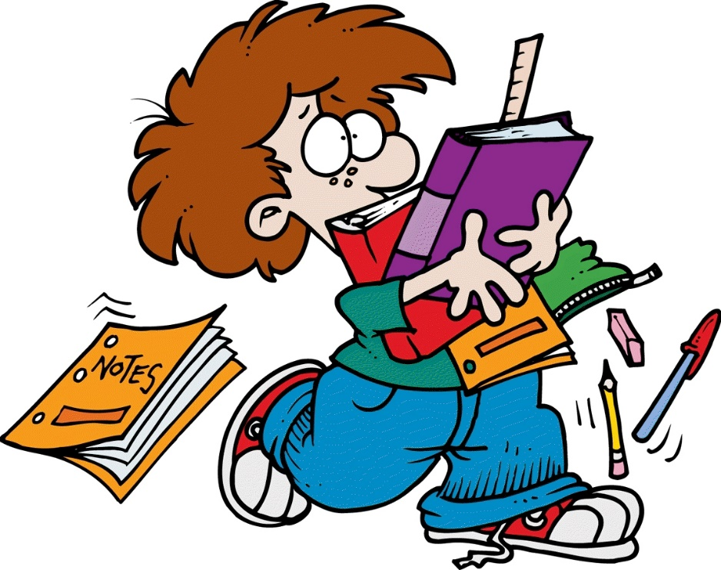

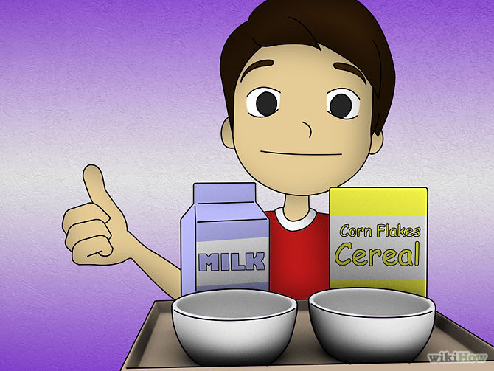

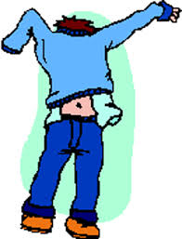

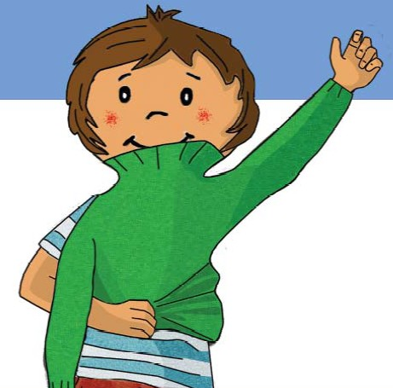

ISABELLA ESPITIA: GOOD MORNING LADIES AND GENTLEMEN, WELCOME TO OUR CIRCUS.
LUIS CAMILO: TODAY WE ARE GOING TO HAVE BEAUTIFUL SHOWS.
ISABELLA ESPITIA: YES LIKE CLOWNS, MAGICIANS, AMONG OTHERS.
LUIS CAMILO: OK SO LET´S START WITH THE FIRST FUNCTION. THEY APPEAR AND DISSAPEAR THINGS. THEY ARE THE MAGICIANS!
PART ONE
CARLOS: OH! HOW MANY PEOPLE THERE ARE HERE TODAY! THAT MAKES US VERY HAPPY! LET´S SHOW THEM WHAT WE CAN DO.
LUIS FER, CAMILO A: HELLO WE ARE THE MAGICIANS! WE MAKE RABBITS APPEAR AND DESAPPEAR, CAMILO: (CAMILO DEBE PRACTICAR ESTA MAGIA http://magic.about.com/od/libraryofsimpletricks/ig/Easy-Tricks-for-Kids/The-Jumping-Rubberband.--Cj.htm )
SEE MY HAND I´M GOING TO MAKE A TRICK WITH THE RUBBERBAND.
LUIS FERNANDO: NOW I´M GOING TO MAKE A TRICK WITH A PENCIL. PLEASE PAY ATTENTION
(LUIS FER DEBE PRACTICAR ESTA MAGIA http://magic.about.com/od/libraryofsimpletricks/ig/Easy-Tricks-for-Kids/The-Rubber-Pencil.htm )
CARLOS: FINALLY I WANT TO SHOW YOU THE FOLLOWING ACT (http://magic.about.com/od/libraryofsimpletricks/ss/121807necklace.htm )
CARLOS, LUIS FER, CAMILO A: WE HOPE YOU ENJOY OUR ACT. THANK YOU SO MUCH.
PART TWO
ISABELLA ESPITIA: BEAUTIFUL ACT NOW LET´S GO TO THE SECOND PART.
LUIS CAMILO: YES, THEY ARE VERY ACTIVE AND ELASTIC.THEY ARE THE ACROBATS
MELISSA: WHAT A BEAUTIFUL DAY! AND LOOK PARTNERS! LOOK AT ALL TTHOSE BOYS AND GIRLS AT OUR CIRCUS.
ALEJANDRA TENJO: YES MELISSA. WHY DON´T WE GIVE THEM A GIFT THROUGH OUR ACT.
SOFÍA SANTOS: YES, THAT´S RIGHT. SO LET´S INTRODUCE THE WHOLE TEAM. (LLAMAN AL RESTO DEL GRUPO)
JUAN JOSÉ CAIPA, DANIEL M, JUAND D: HI EVERYBODY. WE ARE THE ACROBATS, WE CAN DO SO MANY EXERCISES, JUMP, ROLL AND MUCH MORE.
MELISSA: WE ARE GOING TO SHOW SOME OF OUR ROUTINES. LOOK AT THIS.
(LOS ACRIBATAS EMPIEZAN A HACER MEDIA LUNA, SALTOS, BOTES, JUAN DAVID VA EN SU BICIBLETA, VAMOS A SIMULAR QUE VAN A PASAR DE UNA CUERDA A OTRA)
JUAN D: I CAN RIDE A BIKE WITHOUT MY HANDS.LOOK AT MY MOVEMENT. CAN YOU DO IT?
ALEJANDRA TENJO: FOR EXAMPLE I CAN ROLL AND GO UP AND DOWN.
JUAN JOSÉ, DANIEL, JUAND D, MELISSA, ALEJANDRA TENJO, SOFÍA SANTOS: WE HOPE YOU LIKE IT. THANK YOU SO MUCH.
PART THREE
ISABELLA ESPITIA: THANK YOU SO MUCH TO THE ACROBATS. NOW WE ARE GOING TO PRESENT SOME PEOPLE WHO MAKE US LAUGH.
LUIS CAMILO: YES ISABELLA, THEY ARE VERY FUNNY. LET´S RECEIVE WITH A BIG CLAP THE CLOWNS.
MARIA PAULA, SANTIAGO, JULIO: GOOD MORNING LITTLE FRIENDS. WE ARE THE CLOWNS. WE DO MANY THINGS TO MAKE PEOPLE LAUGH. WE HOPE YOU ENJOY OUR FUNCTION.
(POR FAVOR APRENDERSE LA CANCIÓN DE LA PÁG 31 PUPIL´S BOOK. YO LES ENVÍO EL AUDIO EN EL AULA VIRTUAL)
MARIA PAULA, SANTIAGO, JULIO: DID YOU LIKE IT? IF YOU DON´T WE ARE GOING TO START TO CRY BUUUUUUUUUUUUUUUUUUUUUUUUUUU
THANK YOU SO MUCH
PART FOUR
LUIS CAMILO: BEAUTIFUL PERFORMANCE, ISN´T IT ISABELLA?
ISABELLA E: YES CAMILO, THEY ARE VERY FUNNY.

CARTELERA DE DANIELA: BUT THERE´S ONE THING WE CAN DO. IMITATE YOUR ACTIONS.
(CUANDO DANI TERMNE DE MOSTRAR SU CARTEL SE VAN AL PUBLICO PARA IMITARLOS. SE QUEDAN ENTRE EL PÚBLICO Y SALEN LOS MALABARISTAS).
JUAN ESTEBAN: JERONIMO HAVE YOU SEEN THE MIMES?
JERONIMO: NO, I DON´T KNOW WHERE THEY ARE. AND WE HAVE TO WAIT FOR THEM TO START OUR ACT.
OMAR: WE MUSN´T WAIT FOR THEM. LET´S START OUR ACT.
JUAN, JERO, OMAR: HI EVERYBODY. WE ARE THE JUGGLERS. WE CAN DO SO MANY THINGS LIKE THIS.
( EMPIEZAN A REALIZAR MALABARES CON PELOTAS, LAZOS, JERO CON LA BICICLETA).
JUAN, JERO, OMAR: THANK YOU.
ISABELLA: THANKS TO THE MIMES AND JUGGLERS.
LUIS: OK SO THAT´S ALL FOR TODAY. SEE YOU NEXT YEAR
TODO EL GRUPO 4ª: THANKS FOR COMING. (HACEN LA VENIA)

FIN.

